MASCHERPA Audric ROB 3 2022 / 2023
POLY-SNAKE

Meeting report n°1 from 14/10/22 :
Figure 1.1
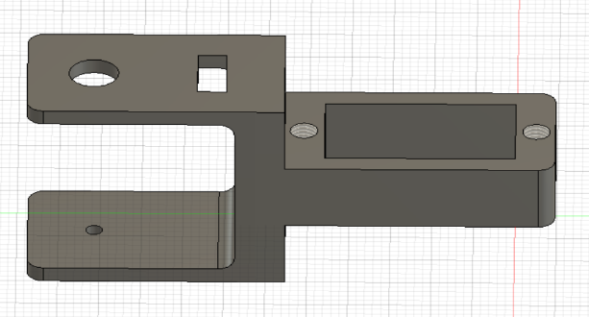
This first session was about the conception and the realization of the 3d printed piece who will make it possible to link the servomotors together.
Indeed, I was working on the conception of the main part of the piece during the first hour of the session and the figure 1.1 show what I produced:

Figure 1.2
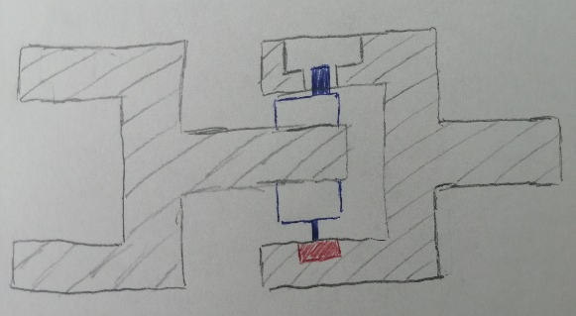
Next, after talking with some of my teachers, I’ve decided to use ball bearings to hold in position the servomotor with the 3D printed piece and reduce friction as much as I can which will allow the snake to be more fluid in these movements. The figure 1.2 show a plan of the piece with servomotor in blue and ball bearing in red which was done in class.
Thus, it will me important to choose on the internet the more adapted ball bearing for the project.

Moreover, I decided during the last 2 hours to change the servomotors of the robot and to use the FS5109M one which is easier to found on the internet and has the same properties of the old one.

Finally, I also decided to realize the first concept of the 3D printed piece in wood to avoid having to print several 3D pieces and therefore waste time. Thus, the wood piece will allow me to find the best technical solution for the piece before 3D printing it.
The last hour was centered on the conception of the wood piece which should be finished the next session of the project. The website uses is https://fr.makercase.com/#/

Meeting report n°2 from 18/10/22 :

First of all, the beginning of this second session was about the choice of position maintenance for servomotors. Indeed, during the last session, the chosen solution was the use of ball bearing but the use of a simple cylinder piece for the maintenance in position is sufficient.

Figure 2.1
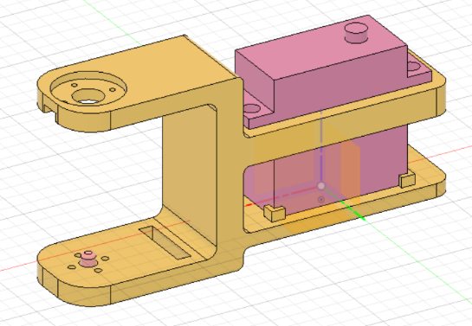
Thus, we chose to leave the ball bearing and use the simplest idea. Then, I forgot the idea of making the wooden piece because of the lack of time, so I chose to upgrade the design the 3d piece during this session. (Figure 2.1). This piece can accommodate a servomotor and keep it in position while allowing stable rotation using the pink piece (in the left of the picture).

Figure 2.2

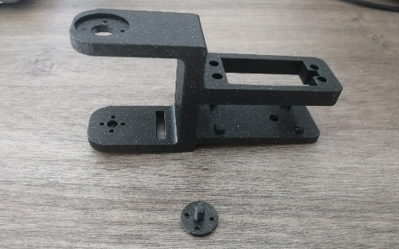
Next, I printed the piece using PETG filament as explain in the bibliography as show the figure 2.2. Unfortunately, due to a lack of precision in the machine, the part does not allow the servomotor to be accommodated. Thus, the next session will focus on the modification of the part as well as the implementation of some new features such as supports for the wheels

Finally, it was decided with my project partner to use the TD-8135MG model as a servomotor because it was closer to our performance requirements than the one chosen at the previous session.

Meeting report n°3 from 28/10/22 :
Figure 3.1
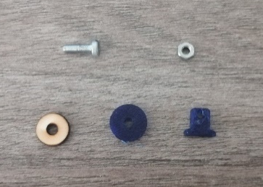
During this third session, I worked on modifying some details of the 3D part modeling. Indeed, I increased the size of the place reserved for the servomotors which was too small as well as other small design details. In addition, I decided during this session to add wheels to allow the system to be able to slide on the ground. So, in order to find the ideal diameter, I first made the wooden wheels (Figure 3.1) with a laser cutting machine in order to find the ideal diameter of the wheels.

Then once the diameter (13mm) was chosen I was able to launch the 3D printing of the wheels as well as their supports which will be connected by a screw and a nut (the goal being for the moment to allow the robot to slide on the floor).
Figure 3.2
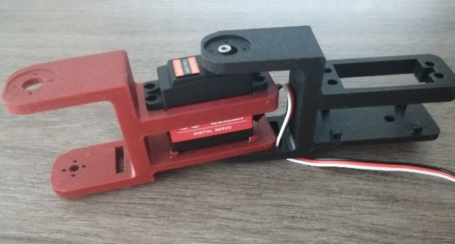
Then I was able, thanks to the part printed in 3D last week and the one printed during the course, to make an assembly of a Poly-Snake module as we can see in the figure 3.2.
Finally, we can see in the Figure 3.3 the current 3D model of the piece. The next session will therefore be devoted to the modification of a few slight details and the pooling of my work as well as that of my partner (who for his part had to carry out the programming of the movement of the snake) in order to test the fluidity of the gestures of the system and the proper functioning of the robot.

(Following a 360 fusion bug, figure 3.3 cannot be displayed during this report)

